Title | Play It Again, Paik
Inquiry | Curator: Lee Soo Young, t. +82- (0)31-201-8596, sylee@njpartcenter.kr  Lee Sangah, t. +82- (0)31-201-8549, sangah@njpartcenter.kr  PR Manager :Kim Jisoo, t. +82-(0)31-201-8542, press@njpartcenter.kr
Press Release | See attached files or Download from link in e-mail
Release Date | April 9, 2025 |  | 12 p
Press
Release

Nam June Paik Art Center
Play It Again, Paik

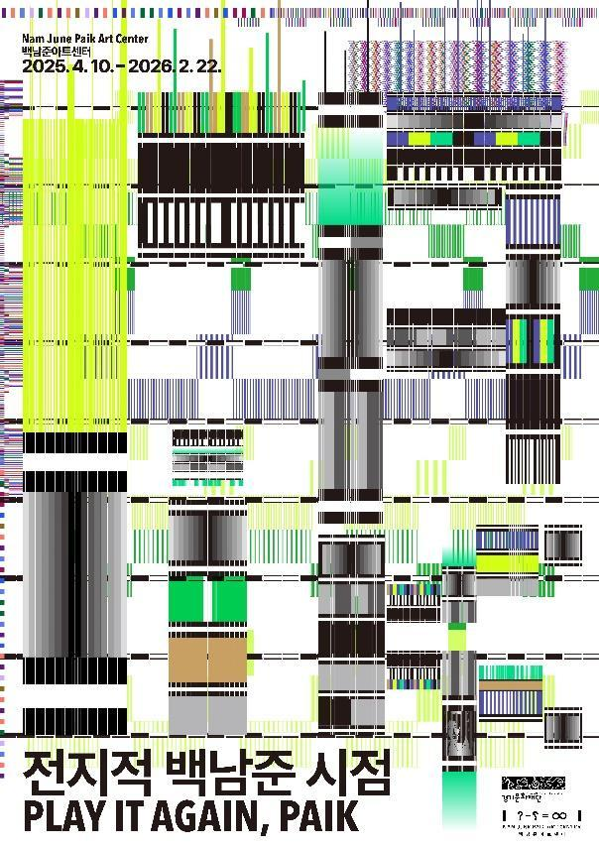
- Play It Again, Paik offers a chance to see Nam June Paik’s works through his own eyes—watching, listening, and reading while getting closer to his experiments with time in video.
- The exhibition brings together early works from the 1960s, like Magnet TV and Participation TV from the Nam June Paik Art Center, along with Uranus, TV Piano, Zen for TV, and Three Camera Participation from Leeum Museum of Art, AK Industrial, the National Museum of Modern and Contemporary Art, and Kunsthalle Bremen—following Paik’s thoughts on time.
- At the opening, actor Ji Choonsung will read Paik’s Random Access Information, and geomungo player Park Dawool will present an improvisational performance.

- Overview
  - Title: Play It Again, Paik
  - Duration: April 10, 2025 – February 22, 2026
  - Venue: Gallery 1, Nam June Paik Art Center
  - Curators: Lee Soo Young, Lee Sangah (Nam June Paik Art Center)
  - Participating Artists: Nam June Paik, Klaus Barisch, Peter Moore
  - Organized by: Nam June Paik Art Center, Gyeonggi Cultural Foundation

    - Exhibition Introduction
Nam June Paik Art Center (Director Park Namhee) of the Gyeonggi Cultural Foundation presents Play It Again, Paik, an exhibition running from April 10, 2025, through February 22, 2026. Centered on archival interview footage of Nam June Paik, the exhibition offers a multilayered exploration of his concept of time. Play It Again, Paik invites the visitors to experience Paik’s works through his perspective, listen to his music, and read his texts while engaging with his video experiments on time. Drawing from its collection of 2,285 video archives, the Nam June Paik Art Center showcases a curated selection of Paik’s interviews, originally broadcast in Korea, the United States, Japan, and Germany. These interviews, shown alongside his artworks, provide an opportunity to witness the artist in action as he explains his works and demonstrates electronic technology.

This exhibition highlights the nature of time as contemplated in Paik’s art and raises questions about its broad possibilities. Moon is the Oldest TV, which depicts the shifting phases of the moon as it waxes from crescent to full across 13 monitors, exemplifies Paik's experimentation with time. He was particularly interested in how video enables new experiences of time. In an interview with WNET explaining Moon is the Oldest TV, he remarked that video artists had discovered “abstract time.” He also stated, “Time you can sense, but you cannot see. I want to make time visible and time you can grasp. Each section of time and put on space. That is our dream.” as he demonstrated the moon’s transformation. Together, the interview and the artwork bring us closer to Paik's experiments in visualizing an “abstract time” devoid of content.

In addition to Moon is the Oldest TV, the exhibition presents ten of Paik's experimental works, including Candle TV, Magnet TV, Participation TV, Paik-Abe Video Synthesizer, and TV Garden, displayed alongside interviews with the artist. In a documentary produced by NHK, Japan’s national broadcaster, Paik elaborates on the concepts and mechanisms behind Participation TV, Magnet TV, and Candle TV. The very Magnet TV demonstrated in Jean-Paul Fargier’s short film Play It Again, Nam! is included in this exhibition, offering a striking sensory experience. In an interview with ARD, a German broadcasting network, Paik discusses Paik-Abe Video Synthesizer, emphasizing the importance of directly engaging with the internet and media, further underscoring his visionary approach as an artist ahead of his time. Three Camera Participation, which was presented in TV as a Creative Medium at the Howard Wise Gallery in 1969, is also a notable work in the exhibition. Archival footage of Paik installing his works provides a unique glimpse into his working methods and creative process.

Alongside the interviews, the exhibition also features video sculptures that reflect Paik's exploration of time. These include Video Chandelier No.1, which illustrates his technological imagination spanning past and present civilizations; Uranus, which expands his artistic vision into cosmic space; and TV Piano, which integrates his musical background with nonlinear temporal structures. Notably, Uranus, an exquisite work composed of 24 monitors and vivid neon lights, will be displayed for the first time since its 2006 exhibition at the Leeum Museum of Art. The exhibition also introduces seven newly acquired photographs by Peter Moore, now added to the Nam June Paik Art Center's collection. Moore’s photographs capture Paik’s artistic presence, including his collaboration with Charlotte Moorman on TV Cello and his experimental interactions with television, offering viewers a closer connection to the artist.

The exhibition concludes with archival objects from Paik's studio, Memorabilia, along with the writings by Paik himself. Items such as small toys, letters, and other personal artifacts provide an intimate look into the artist’s world. Accompanying these objects are six of Paik’s texts, including Random Access Information, Input Time and Output Time, and Afterlude to the Exposition of Experimental Television, excerpted from Paik: Du Cheval à Christo Et Autres Écrits (translated as Paik: From the Horse to Christo and Other Writings). These writings offer deeper insight into the exhibition. This exhibition seeks to rekindle the spirit of Paik’s ideas and provide an opportunity to reflect on his lasting influence.

Opening Event & Related Screenings
The opening event will feature a reading of Paik’s Random Access Information, a text based on his 1980 lecture at the Museum of Modern Art in New York, in which contains a narrative about time and video. The reading will be performed by actor Ji Choonsung. Additionally, geomungo musician Park Dawool, known for his appearance in a TV show Super Band Season 2 and for pushing the boundaries of traditional Korean music, will present an improvisational performance with pianist Kim Joonseo.
In conjunction with the exhibition, the Nam June Paik Art Center will host Random Access Hall Screening from May to December, presenting video works and documentaries of Nam June Paik. This screening program will showcase a selection of Nam June Paik’s works and related documentaries, featuring full-length versions of the interview footage included in the exhibition. The screenings will begin with Paik's My Mix '81, continued with Jean-Paul Fargier's short film Play it again, Nam!, followed by Nam June Paik: Edited for Television and TV as a Creative Medium from WNET, an American broadcasting corporation, and the documentary Archaeology of Avant-garde/Das Gute Gewissen der Avante Gards (translated as The Good Will of Avant-garde) from WDR, a German public broadcaster. These monthly screenings aim to provide viewers with an accessible entry point into Paik’s artistic universe.

- Works

A. Nam June Paik, Suite 212: Selling of New York, 1975 (1977), 8:10, color, sound
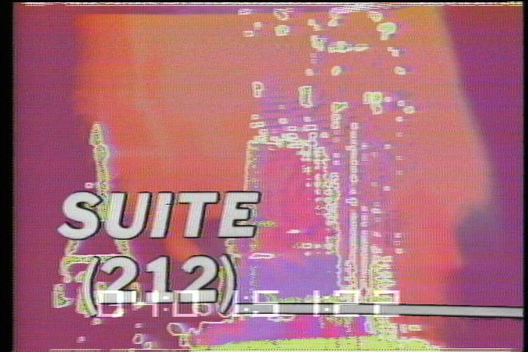

Selling New York is one of the most representative pieces from Suite 212, a video show produced by New York's WNET television station. The program, which comprised over 30 short video segments, aired as the final broadcast of the day. The rapid editing of electronic collage using a video synthesizer, combined with lively sounds, gives the work a music-video-like feeling. These pieces, which reflect the multiculturalism of New York, a cosmopolitan and vast city, offer a diverse perspective. Named after New York's area code, 212, the series featured personal video sketches by Nam June Paik. The most famous of these, Selling New York, depicted the city’s dominant broadcast and television networks. The work cleverly juxtaposes the power of mass media, both commercial and political, with the passive consumption of television in everyday life. Accompanied by the narration “seeing media through media,” it concludes with Paik's early television experiments and Douglas Davis's televised meditations.

B. Nam June Paik, Random Access Audio Tape, 1963 (1975), chipboard 71×130cm, portable cassette player 14×25×8cm, chipboard, plastic foil, audio tape strips, portable cassette player, magnetic tape head

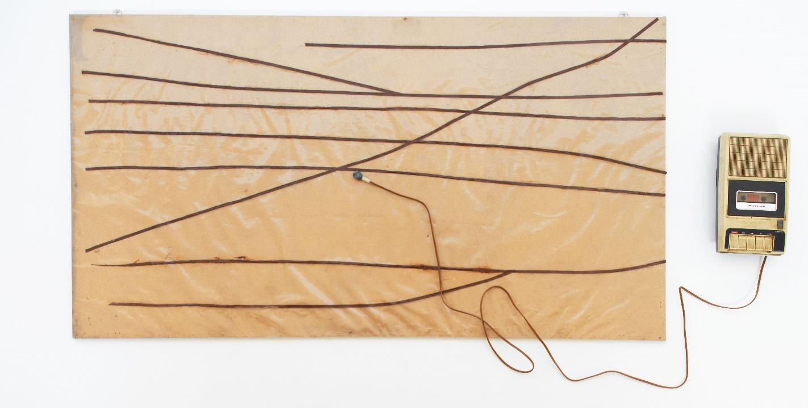
In his first solo exhibition in 1963, Nam June Paik presented Random Access, a work in which he unwound a recording tape, mounted it on the wall, and allowed viewers to listen to the recorded sound by running the tape directly across the wall with a metal head that was removed from the playback device. The term “random access” refers to the ability to access all tracks in a list within a set period, enabling users to directly and immediately access stored data, regardless of its location. Random Access Audio Tape is a portable cassette player with a playable metal head attached to a wooden board. Like the original work, the portable Random Access Audio Tape allows viewers to scratch the tape to hear “random” sounds. The music that played varies depending on the direction and speed at which the viewers scratched the tape. Through “random access”, he experimented with the materiality of magnetic tape and the possibility of freely altering its linear structure. Paik extended this conceptual experimentation with coincidence and time to video.

C. Nam June Paik, Moon is the Oldest TV, 1965 (2000), dimensions variable, 13 CRT TV sets, 12-channel video, color, silent, LD; E-Moon, 1-channel video, color, sound, DVD

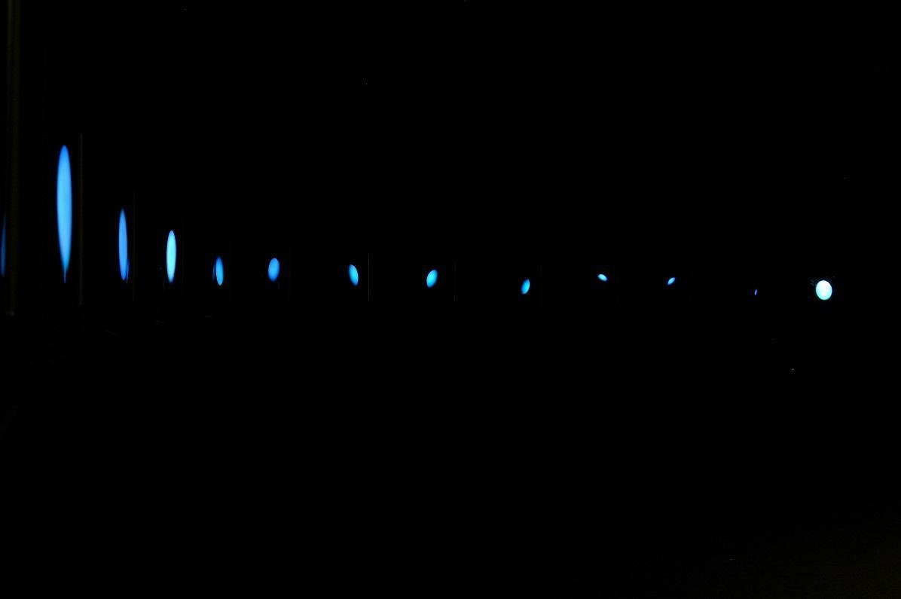

Moon is the Oldest TV consists of 13 monitors displaying various lunar phases, from crescent to full moon. When Nam June Paik first exhibited this work in 1965, he was experimenting with modifying cathode ray tubes and television internals to create abstract imagery. Moon is the Oldest TV also uses a deflector at the end of a cathode ray tube to alter the electromagnetic flow, creating the effect of a pale moon floating on the screen. Paik once explained that video artists had discovered abstract time, which he defined as time without content. While the lunar cycle represents natural time, imbued with its rhythmic patterns, Paik's “Moon” is not a playback of the real moon. If the moon were filmed and shown, it would capture not a still moment, but the changing moon and Earth's movement. Only through Paik's unique approach can a static moon, a frozen moment in time, an eternity, be shown.

D. Nam June Paik, Uranus, 1991, 243.8×243.8×81.2cm, round steel beam, 24 CRT TV sets, 2-channel video, Leeum Collection

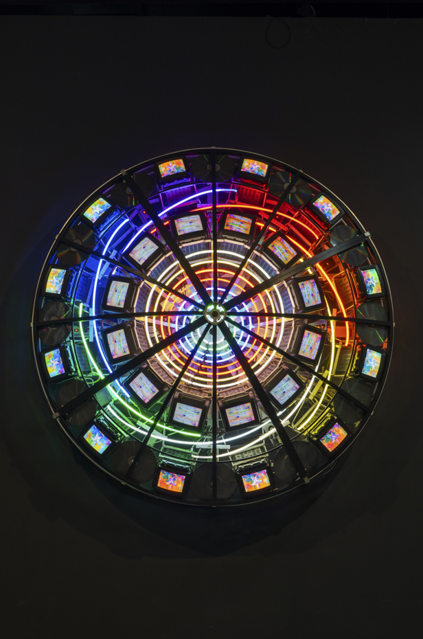
Uranus is an expression of Nam June Paik's cosmic imagination, encapsulated within his trilogy of satellite operas and planetary series. Paik amplified global communication and imagination by connecting New York and Paris through a satellite live broadcast. He expanded his vision of the universe through the planetary series, which includes works such as Sun and Moon, Venus, Mars, and Neptune. Uranus, the seventh planet in the solar system, appears turquoise due to methane in its atmosphere and features hazy ice rings. In Uranus, Paik combines colorful neon lights with 24 monitors displaying various images. The radiant visuals flickering across the 24 screens create a poetic portrait of the universe, bridging the fleeting and the eternal.

E. Nam June Paik, Three Camera Participation, 1969 (2001), dimensions variable, three videocameras, video distribution amplifier, video boost amp, monitor and projector with RGB input and output, theatre lights, Kunsthalle Bremen – Kunstverein in Bremen Collection
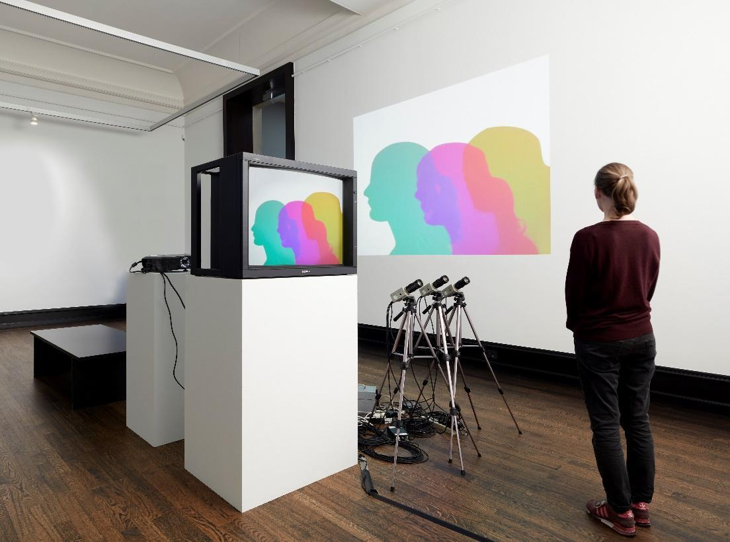

Three Camera Participation is a work in which colorful shadows appear on a television connected to three black-and-white cameras. Each camera illuminates the subject with red, green, and blue electron beams inside the television, and the three colors merge on the screen through equipment and amplifiers that synchronize the signals between the cameras and the television. The setup is also connected to a projector, which casts the image onto the wall, creating equally beautiful shadows. Reminiscent of shadow play, the piece invites viewers to reflect on their own perception and representation of reality. Nam June Paik discovered the potential of experimental video by using simple technology to create the desired scene, thus replacing expensive color cameras.

F. Nam June Paik, TV Piano, 1998, 265×10×269cm, 1 videocamera, 16 CRT TV sets, 1 piano, 3-channel video, Courtesy of AK Industrial

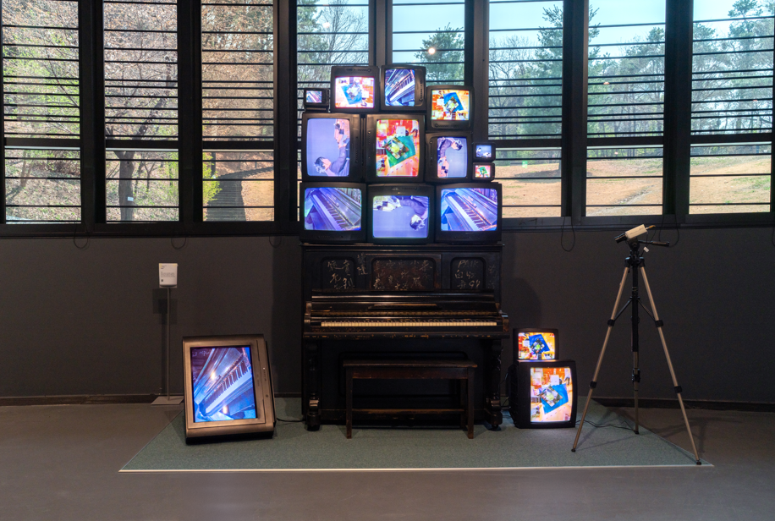

Nam June Paik had learned how to play piano and compose from a young age, nurturing his dream of becoming a composer. When he first showcased experimental television in a solo exhibition, he titled the show Exposition of Music and described the work simply as “time-art.” Video art, too, is based on time and governed by its flow. In this regard, TV Piano is a work that best showcases Paik's exploration of music and video, centered around time. Twelve televisions are stacked irregularly on top of a piano. Some televisions display real-time footage from the piano, filmed through closed-circuit cameras, while others show Paik's performance. In the video, Paik holds the camera in his hands and plays it as if pressing the piano keys. Paik's video piano performance creates a beautiful, non-linear sense of time.

G. Nam June Paik, Shigeko Kubota, Allan 'n' Allen's Complaint, 1982, 27:40, color, sound
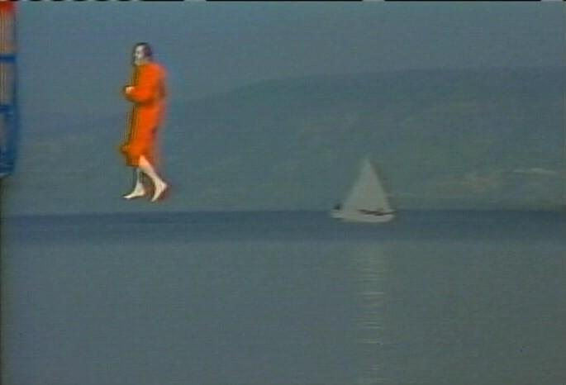

Allan 'n' Allen's Complaint is a video that explores the relationship between two artists and their father, demonstrating the potential of video to capture the past and reframe it into a new narrative. These two artists, grappling with conflict with their patriarchal Jewish father, seek to create a new order and art. Through video synthesis, Nam June Paik allows Allan and Allen to overcome the time and space limitations that have long hindered them. Allen Ginsberg, the iconic poet of the Beat Generation, meets and converses with his father, who led a life completely different from his own, in a video synthesized on the same screen three years after his father's death. Performance artist Allan Kaprow attempts, unsuccessfully, to walk on water like Jesus, but Paik uses video compositing to make this impossible feat possible. While the scenes in the high-speed video maintain a playful and lively atmosphere, Paik's video experiments take a serious turn, offering a multidimensional experience that transcends the constraints of time and space.

G. Peter Moore Collection

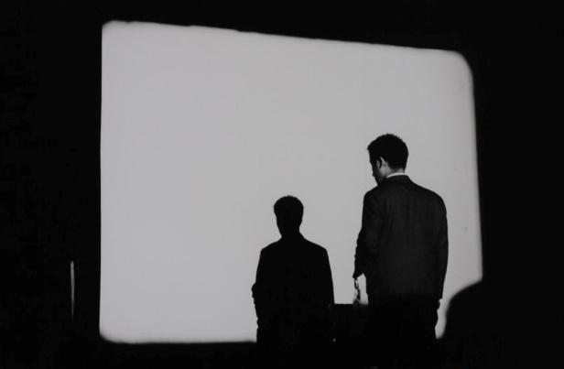 | 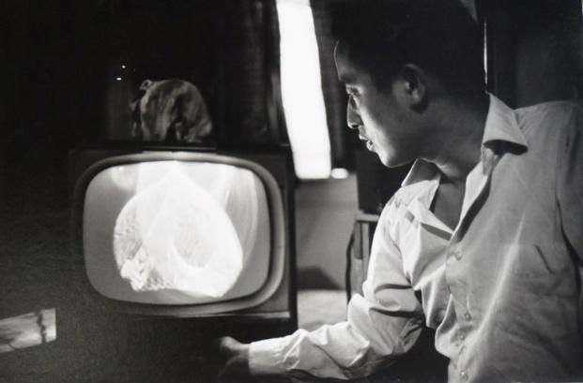
Zen for Film, New Cinema Festival I, Film-Makers' Cinematheque, New York, 1965 | Magnet TV, Canal Street studio, New York, 1965
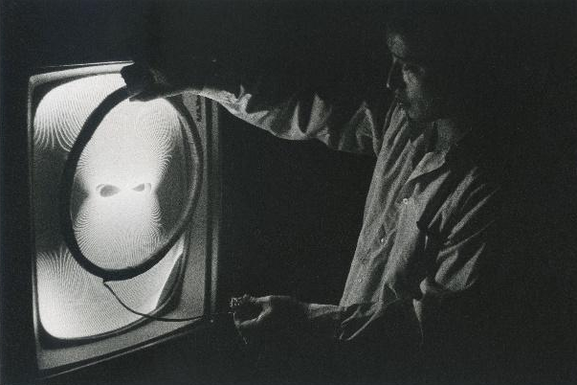 | 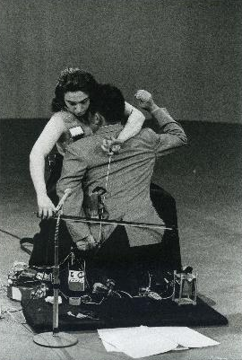
Untitled (Nam June Paik with his "Demagnetizer" or "Life Ring"), 1965 | Charlotte Moorman and Nam June Paik performing John Cage’s 26’1.1499” for A String Player (“Human Cello”), Channel 13 TV Studio, 1971

Peter Moore was a member of the New York art community from the early 1960s, capturing the energy of experimental performance art by photographing Fluxus, the Judson Dance Theater, and many other happenings. Moore understood the fleeting nature of performance, saying, “If I don't record these, they'll be lost.” He continued his photographic documentation for three decades, leaving behind a vast archive. Moore's photographs of Nam June Paik reveal intense, sculptural moments within the continuous time of performance: Paik in front of a screen in Zen for Film, Paik clutching a magnet to create a television image, Charlotte Moorman on the verge of drowning in a barrel filled with water, and Paik walking with a violin in tow. Moore's photographs show that the instant a movement occurs is when art is brought to life.

    - Opening Program
- Nam June Paik’s Random Access Information recited by Ji Choonsung, actor
April 10, 3:00 PM / Nam June Paik Art Center 1F Random Access Hall
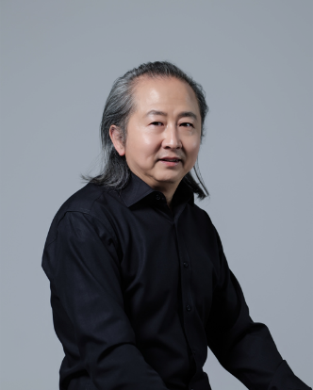 | Actor Ji Choonsung, who will give a reading of Random Access Information, made a significant mark on the theater scene in 1992 with Dongseung (translated as The Young Monk) and has since appeared in over 80 productions, including The Chronicles of Alibi. He has received several accolades, including Best Actor at the 15th Seoul Theater Festival, the Acting Award at the 35th Seoul Theater Festival, and the 2014 Heeseo Theater Award for Theater Artist of the Year. In 2023, he portrayed the role of a father in the play Conservator, delivering a performance that delved into Nam June Paik’s inner world.
Ji Choonsung

- Opening Performance by Park Dawool (guest. Kim Joonseo)
April 10, 5:00 PM / Nam June Paik Art Center 1F Lobby
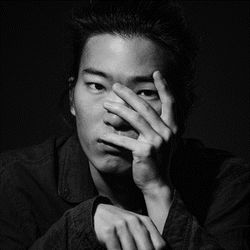 | Park Dawool is a geomungo player recognized for his innovative performances that push beyond the traditional playing techniques of the instrument. He was the music director for Geomungo Paradox: Geomungo is not a Percussion (2022) at the Yeowoorak Festival and participated in G-e-o-m-u-n-g-o (2022) at SyncNext. In 2024, he collaborated with artist Ryu Sungsil and pansori singer Yu Taepyungyang as part of Round and Round at Sejong Center’s SyncNext. Expanding his artistic scope across various fields, he is also a member of the band KARDI, formed through Super Band Season 2(2021).
Park Dawool

    - Exhibition Guide Services
◦ Docent Tours
- Schedule: Tue-Fri 2:00 PM, 4:00 PM
/ Sat-Sun 11:00 AM, 1:00 PM, 2:00 PM, 4:00 PM
- Participation: No reservation required
◦ Audio Guide: Available via the QPickr app

    - Visitor Information
◦ Admission: Free
◦ Hours: 10:00 AM - 6:00 PM (Last admission is 1 hour before closing)
◦ Closed: Mondays

